EDRC Use Case 1, Test Case 1, Section 6.1.2 Enumerated Class Of Capacity
Revision of EDRC doc:

11 | Updated to reflect comments from David Price | K Willshaw  30 March 2015

Test case spec release 1.0

6.1.2 Other Capacity

There is also an entry for OTHER in which the intent seems to be that the Engineer write in the appropriate property name. This is clearly NOT amenable to automation and cannot be mapped as such. However it would be possible to map the Cell to a List of Possible Options using Cell Validation Rules such that one of a range of VolumeFlowrate Properties could be selected. Examples are shown in the list below

In the RDL we store an instance of the template meta model, and this can be seen as the top in a hierarchy of template specializations, down to the project data.
I write this in the context of this subject, because it is possible, at RDL level or at the level of a local RDL extension, to use a template called PicklistOfClasses together with a number of instances of the template EnumerationOfClass. That defines (here) a picklist of allowable ways to express the pump capacity.

At the project level a choice can be made from that picklist, or if made independently the picklist can be used to validate the input.

To do this we would have to create an Enumeration of Class Which is in effect a List of the Classes we want to use for our picklist using the template below

EnumerationOfClass

Role No | Role Name | Role Object Type | Remarks & Examples
1 | hasSet | dm:EnumeratedSetOfClass | ID to be automatically generated
2 | hasMember | dm:Class | here: an instance of ClassOfIndirectProperty

Typical list of Classes in the Enumeration
Datasheet Field | Field Type | ISO 15926 Designation | ISO 15926 Entity Type
Actual | Numeric | ACTUAL VOLUME FLOW RATE | SinglePropertyDimension
Design | Numeric | DESIGN VOLUME FLOW RATE | SinglePropertyDimension
Minimum | Numeric | LOWER LIMIT VOLUME FLOW RATE | SinglePropertyDimension
Maximum | Unit of Measure | UPPER LIMIT VOLUME FLOW RATE | SinglePropertyDimension

Note the Classes above have been incorrectly typed in the current rdl. They should be classified as ClassOfIndirectProperty

Comment – the hasClass and hasSetOfClass complete role specification did not exist in the provided template library, so it was added.

Comment – the tpl:PickListOfClasses template is missing the “exactly one” OWL constraint on hasClass, so it was added to the template specification.

Comment – the tpl:PickListOfClasses template is missing the “minimum one” OWL constraint on hasSetOfClass, so it was added to the template specification.

PicklistOfClassesTemplate
Role No | Role Name | Role Object Type | Remarks & Examples
1 | hasClass | dm:Class | ID to be automatically generated (this is here an instance of dm:ClassOfIndirectProperty, that is the union of the member Classes of the EnumeratedSetOfClass
2 | hasSetOfClass | dm:EnumeratedSetOfClass

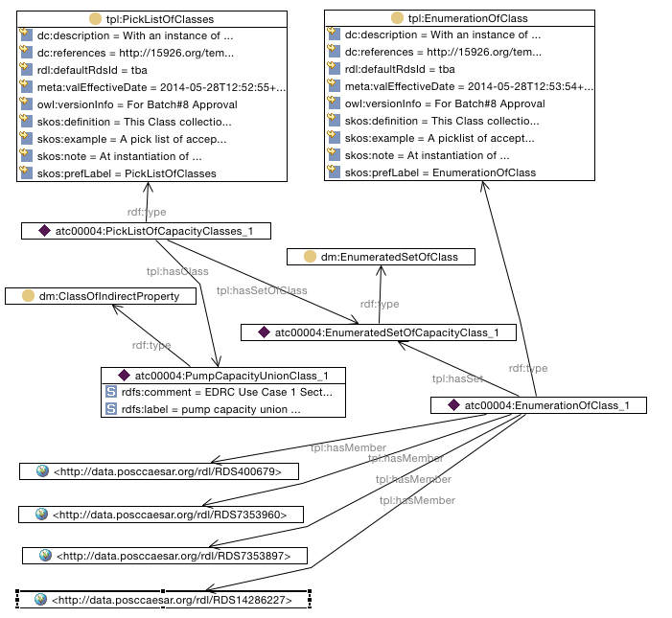

SPARQL to find EnumeratedClassOfCapacity of Pump (one enum only)

SELECT ?ClassLabel ?ClassMember
WHERE {
?enumerationofclass tpl:hasSet ?enumeratedsetofclass .
?enumerationofclass tpl:hasMember ?ClassMember .
?enumerationofclass rdf:type tpl:EnumerationOfClass .
?enumeratedsetofclass rdf:type dm:EnumeratedSetOfClass .
?class rdf:type dm:ClassOfIndirectProperty .
?picklistofclasses tpl:hasSetOfClass ?enumeratedsetofclass .
?picklistofclasses tpl:hasClass ?class .
?picklistofclasses rdf:type tpl:PickListOfClasses .
?class rdfs:label ?ClassLabel .
}

